Name:

|  |  |  |
| --- | --- | --- |
| Problem | Points | Score |
| 1(a) | 15 |  |
| 1(b) | 15 |  |
| 2(a) | 15 |  |
| 2(b) | 15 |  |
| 3(a) | 25 |  |
| 3(b) | 15 |  |
| Total | 100 |  |

Notes:

1. The exam is closed books and notes except for one double-sided sheet of notes.
2. Please indicate clearly your answer to the problem.
3. If I can’t read or follow your solution, it is wrong and no partial credit will be awarded.

**Problem No. 1**: Introduction to Signals and Systems

(a) The fan in my office, which looks something like the picture shown to my right, sounds something like [this](http://www.isip.piconepress.com/courses/temple/ece_3512/exams/2014_fall/exam_01a_fan.mp3) (ask me to play the audio signal in class). Using concepts described in this course over the past few weeks (e.g., discrete-time, digital, random, nonstationary...), describe this signal as completely as possible if you were to record it on your laptop and save it as an MP3 file. The image shown is a plot of the signal in Audacity along with its spectrogram.

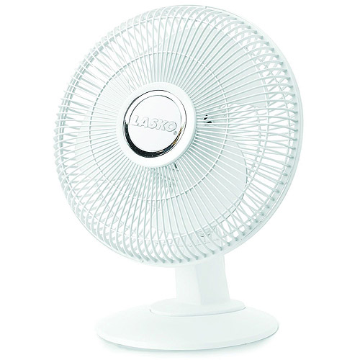

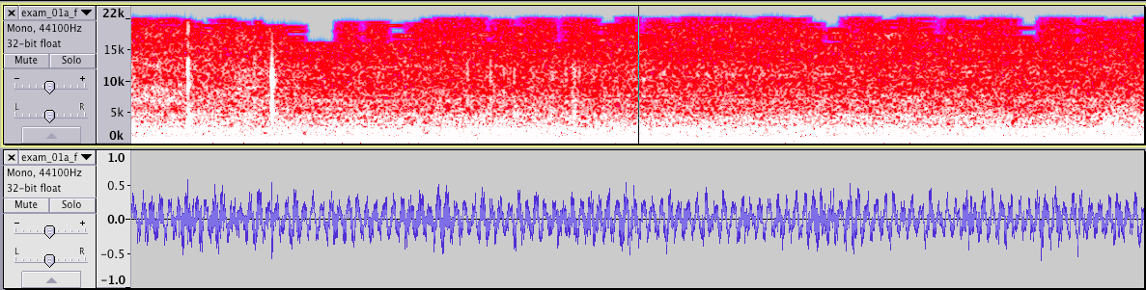

(b) The function shown to the right represents a signal, x(t). Sketch the integral of this function as a function *t*: . Be as precise as possible labeling all critical points on your sketch with actual numeric values. (**Big Hint:** **SKETCH** the signal to be integrated.)

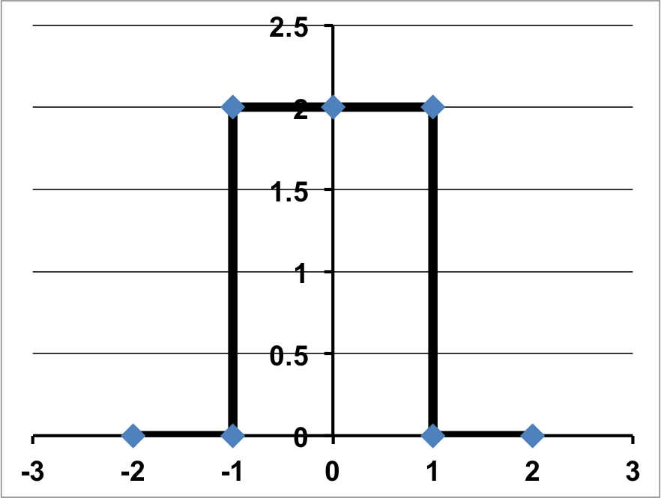

**Problem No. 2**: Energy and Power

(a) Is the signal  an energy signal, a power signal, or neither? Prove this by computing its energy or power, and using that result to support your conclusion.

(b) Suppose . Would that change your answer to (a)? Explain? (Hint: sketch the signal.)

**Problem No. 3**: Assume the voltage source in the circuit shown on the next page consists of the PERIODIC signal shown below (only a few periods are shown). Assume the capacitor is initially discharged and we are interested in the steady-state behavior of the circuit.

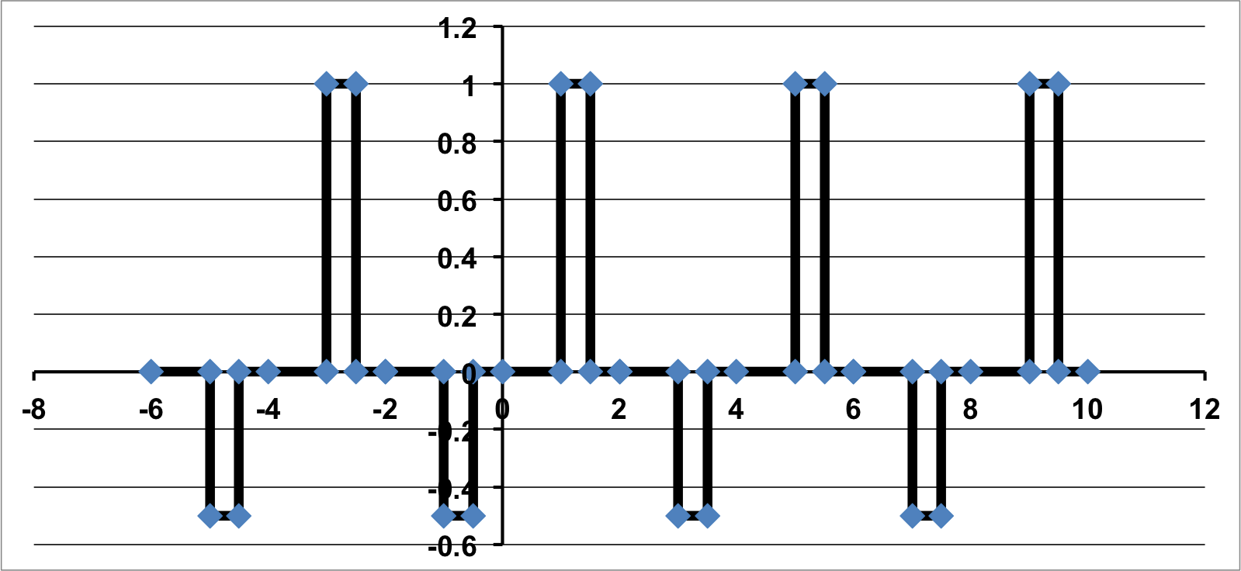

(a) Compute the Fourier Series of the voltage source. Use the complex Fourier Series representation. Simplify as much as possible using symmetry considerations. What coefficients will be zero? Why? You need not work out every integral. If you believe there are no simplifications possible, state your reasons why and leave the integral unsolved.

(b) Sketch the shape of the voltage across the capacitor. Think about this carefully. Think about what each term of the Fourier series implies and how the capacitor behaves as a function of frequency (e.g., as frequency increases, its impedance ???).

